**Ideation Phase**

**Define the Problem Statements**

| Date | 25-08-2025 |
| --- | --- |
| Team ID | LTVIP2025TMID61022 |
| Project Name | Book Nest:Where Stories Nestle |
| Maximum Marks | 2 Marks |

**Customer Problem Statement  
To define the core problems readers face while accessing and discovering books, and use those insights to guide the development of BookNest.**

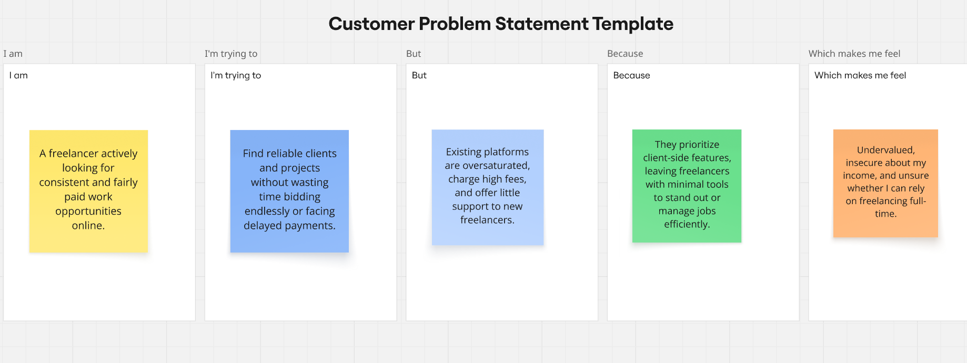

|  |  |  |  |  |
| --- | --- | --- | --- | --- |
| **Problem Statement (PS)** | **I am (Customer)** | **But** | **Because** | **Which makes me feel** |
| **PS-1** | a student and avid reader | most books are expensive or unavailable | I can’t buy or borrow as many books as I want | left out, limited, and discouraged from reading more |
| **PS-2** | a working professional who enjoys reading | recommendations online are too generic | platforms don’t personalize suggestions to my taste | overwhelmed and unsatisfied with my reading journey |
| **PS-3** | a parent who wants to build a reading habit in my child | bookstores and apps don’t guide me well | age-based personalized recommendations are missing | confused, frustrated, and less motivated to encourage reading |